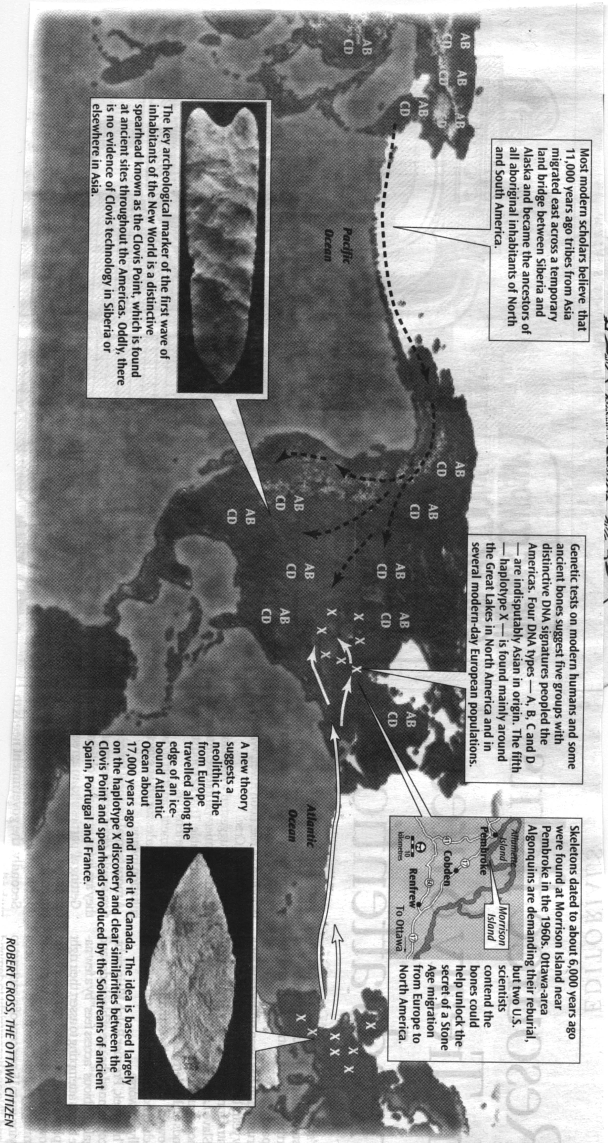
Bridge over ancient waters
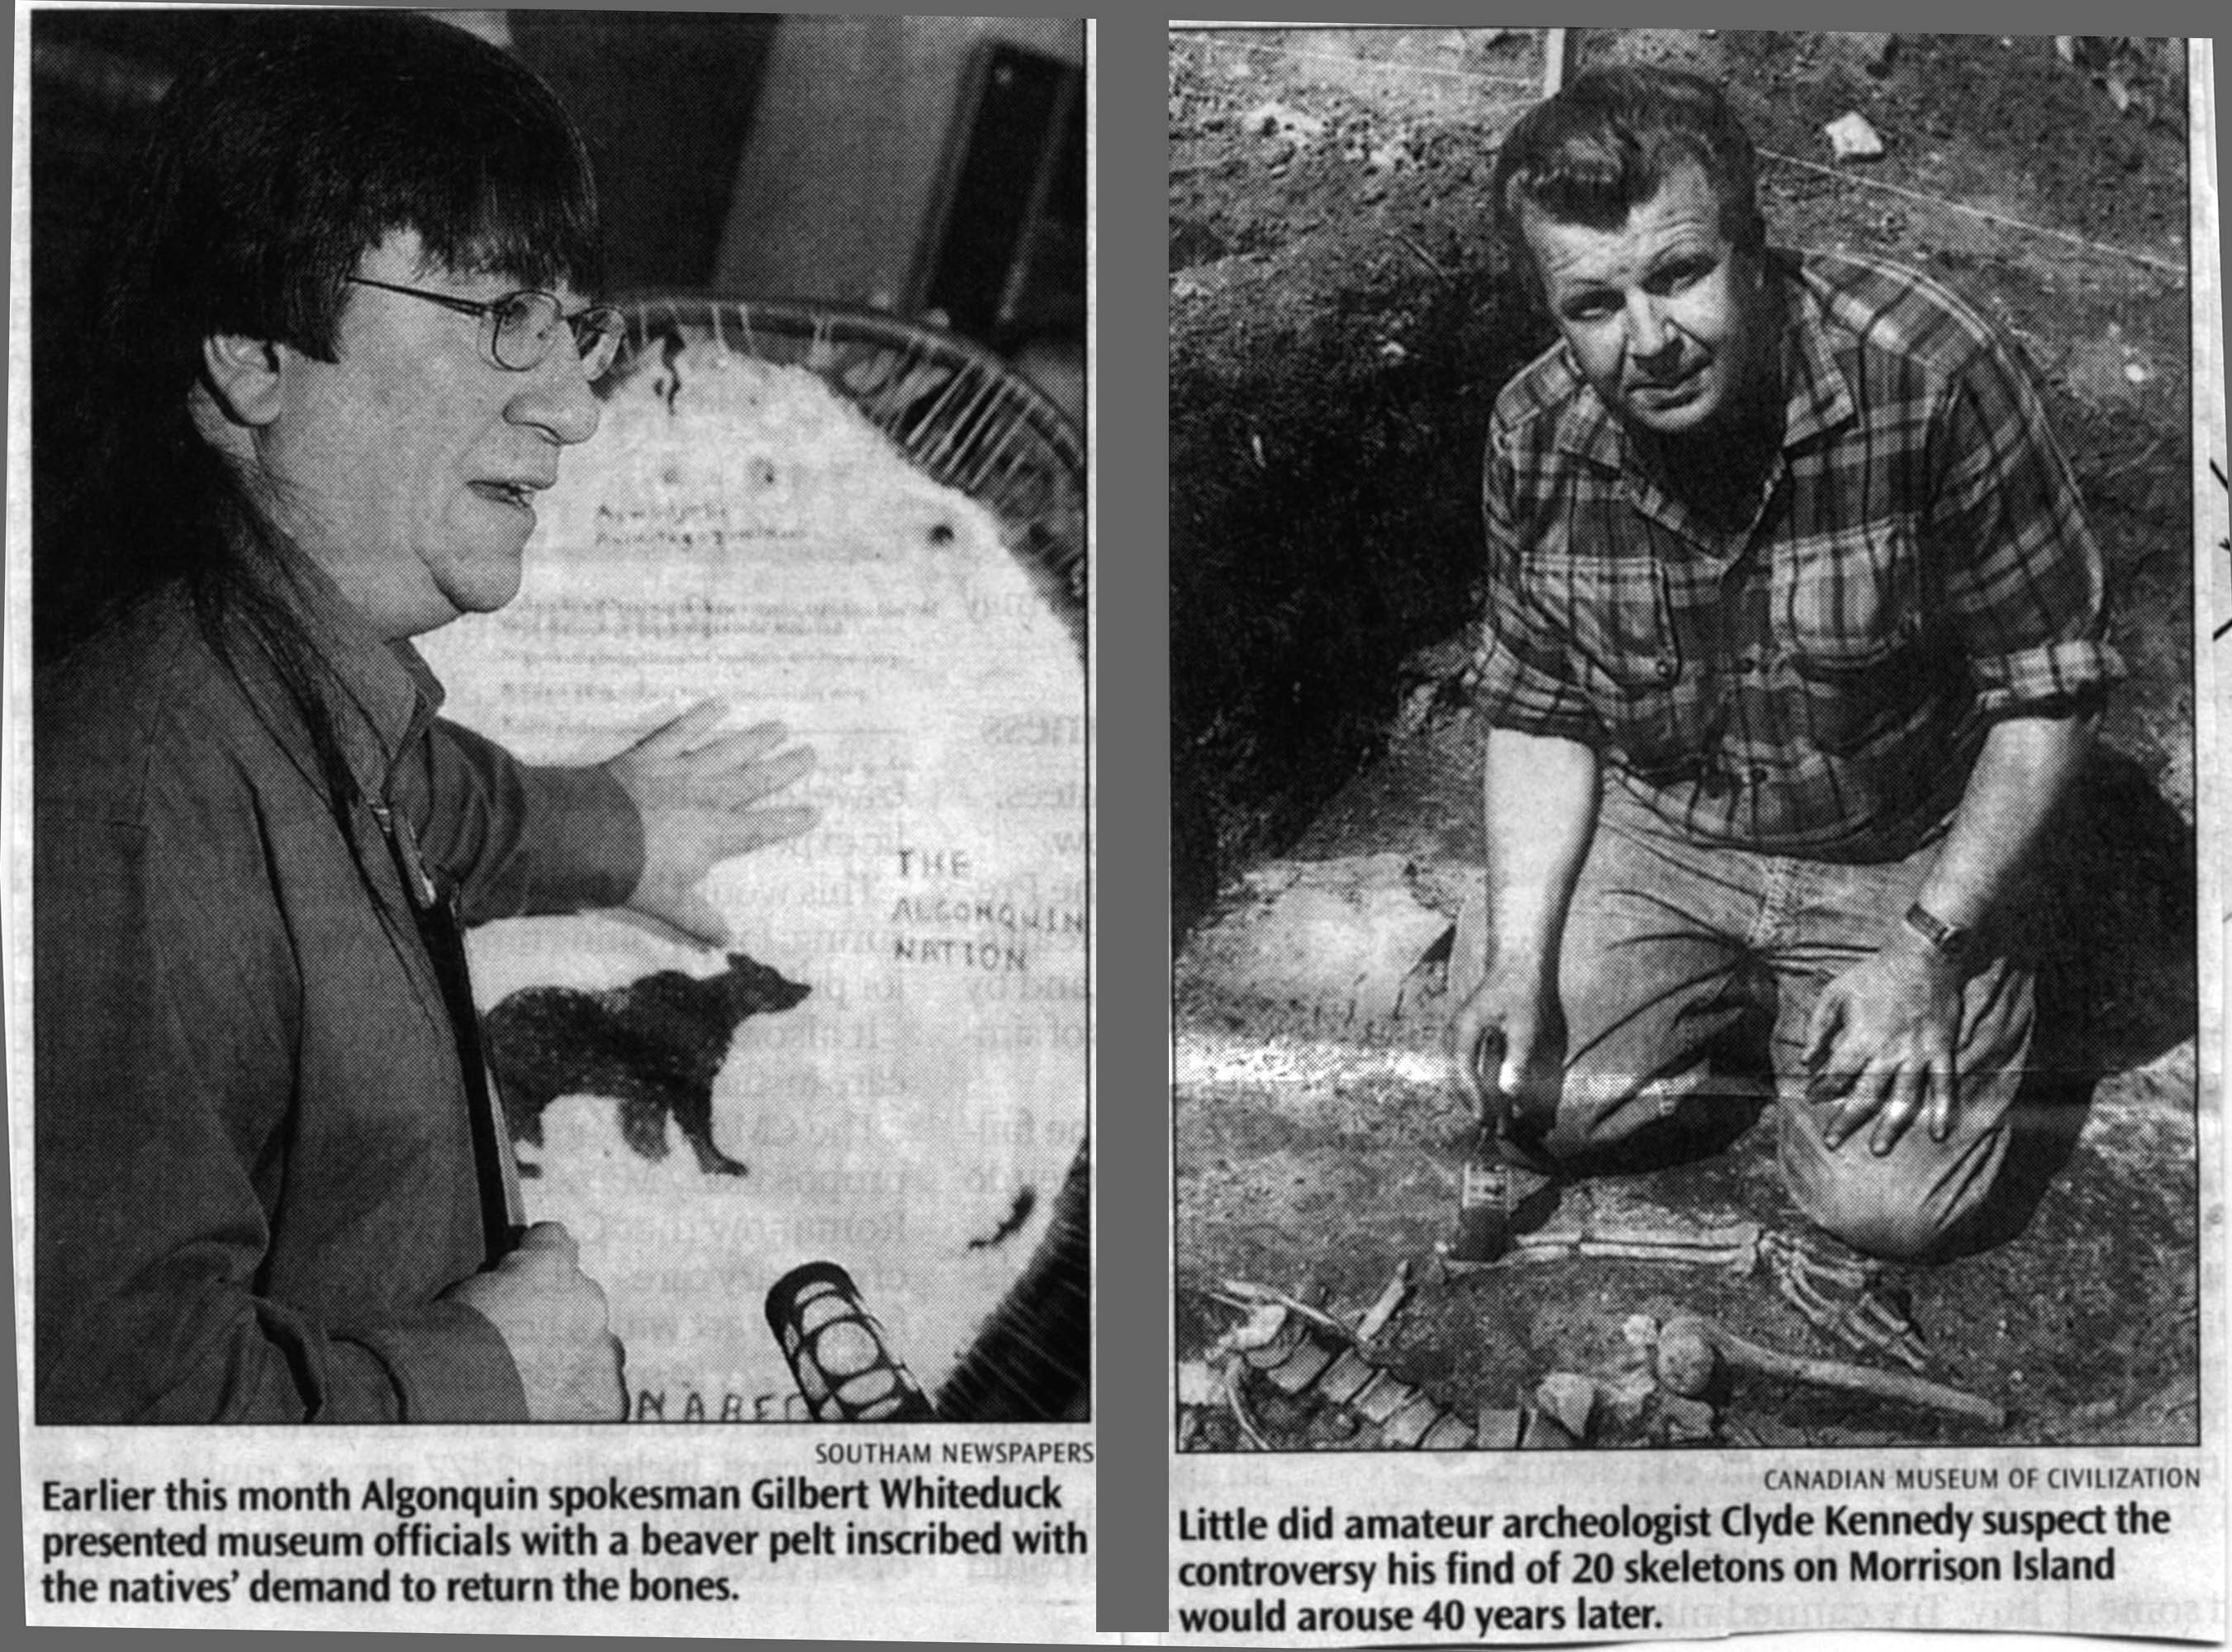

Tantalizing similarities in Palaeolithic tools and DNA suggest some natives came from Europe, not Asia, say two U.S. scientists. They say ancient bones found near Ottawa could hold the key to the mystery

RANDY BOSWELL
Southam Newspapers
Ottawa
When amateur archaeologist Clyde Kennedy began unearthing aboriginal remains on Morrison Island in the summer of 1961, the public relations officer for Atomic Energy of Canada Ltd. Could not have imagined the epic controversy his stunning find would one day generate
Four decades later, the 20 skeletons exhumed from the site near Pembroke, Ont., on the Ottawa River northwest of the nation’s capital—along with bones from nearby Allumette Island, hundreds of prehistoric tools and other traces of a remarkably vibrant prehistoric community—are at the centre of a high-profile clash between the Museum of Civilization scientists who now possess them, and modern-day Algonquins.
For the archaeologists, the remains are a potential source of rare insights into the complex archaic culture, which they are only beginning to understand; for the Algonquins, those remains are their desecrated ancestors and should be returned to Mother Earth.
Now, two widely respected American scientists have dramatically heightened the stakes of the struggle. They argue that DNA testing of the 6,000-year-old bones from Morrison Island could help solve one of the central mysteries of human history: how, at least 10,000 years ago, Stone Age people from the Old World made their way through hostile Arctic environments to finally extend the realm of homo sapiens to new continents in the Western Hemisphere.
More specifically, these bones might provide evidence for the tantalizing possibility that some North American natives originally came from Europe, not Asia.
Kennedy, whose death in 1987 eventually led to the museum’s acquisition of the Morrison Island archaeological treasure, might be spinning in how own grave today. Or he may be smiling down with satisfaction that his scientific moonlighting 40 years ago has left such a rich legacy that it is coveted by both the aboriginal heirs of the Ottawa Valley and acclaimed researchers from around the world.
Challenge to consensus
The quest to understand the peopling of the New World has been at the forefront of academic research since the 19th century.
Archaeologists, anthropologists and linguists have hotly debated the origins and migrations of the Neolithic travellers who somehow came to discover – eons before Columbus – the uninhabited lands of North and South America.
But a consensus gradually emerged and solidified into a “fundamental premise” of 20th-century science: that about 11,000 years ago, at the end of the last Ice Age, Neolithic tribes from Asia migrated east across a temporary land bridge between Siberia and Alaska and became the ancestors of all aboriginal inhabitants of the Americas.
The key archaeological marker of that first ancient wave of New World settlers is a distinctive spearhead known as the Clovis Point, which is found at so-called “palaeo-Indian” sites everywhere from northern Canada to southern Argentina.
But oddly, there is no evidence of such technology in Siberia or elsewhere in the eastern Asian expanse that scientists believe must have given rise to the Clovis culture that apparently crossed the Bering land bridge and quickly dispersed throughout the Americas.
Archaeologists such as Dennis Stanford, one of the world’s leading Clovis experts and head of palaeo-Indian studies at the prestigious Smithsonian Institution in Washington, D.C., figured it was just a matter of time before the same kind of large, leaf-shaped spearheads used by Canada’s first inhabitants would turn up at Siberian dig sites.
“I was working in Alaska and Siberia, knowing full well the connection was there,” recalls Stanford. But access to Soviet-controlled archaeological connections was limited. With the advent of democracy, “finally we were able to get into Siberia and start dealing with Russian colleagues. And, all of a sudden, it became clear (the connection) wasn’t there.”
Disconnect in classic theory
The absence of Clovis-like projectile points in Asia had always worried some out-of-Asia theorists. But it had gradually become assumed that the intrepid travellers who made it to North America also had the means to develop new tools for hunting mammoths and the other large mammals that were their prime food source.
Clovis Points, it has been reasoned, were simply a New World invention.
But the apparent disconnect in the classic theory continued to bother Stanford. And, along with a small minority of academic colleagues, he began giving second thought to a suggestion made by some scientists in the early 20th century (and quickly dismissed) that Clovis Points bear a striking resemblance to stone spearheads used until about 20,000 years ago by the Solutrean culture in the Iberian Peninsula.
By comparing the distinctive DNA mutations from deep-rooted ethnic communities around the world – including native Canadians and other aboriginal groups in the Americas – scientists have been able to create maps showing the likeliest geographic origins of New World populations and the amount of time that has elapsed since their ancestors’ departure from the Old World.
For this reason, the secrets held in mitochondrial DNA have been described as “a biological Rosetta stone for decoding human origins,” referring to the ancient tablet that enabled Egyptologists to crack the code of hieroglyphics.
Much of the work done to chart specific DNA “haplotypes” has reinforced the out-of-Asia theory about migrations to North America. The four major DNA signatures among present-day aboriginal populations in Canada and the United States – labelled A, B, C, and D – can be reliably traced to populations in Asia. About 20 other population groups – such as L for the major DNA type in Africa and M for the largest Asian haplotype—have been similarly designated.
But a fifth “founding lineage” of North American aboriginals – given the name “X” only because it followed next in the alphabet – was more recently discovered by the Wallace team, and has proved to be every bit as mysterious as the letter suggests.
Great Lakes region rich in ‘X’
That DNA signature is found principally among Algonquian-speaking First Nations in the Great Lakes region of Canada and the U.S. Haplotype X is virtually absent from Asia, and the only other significant concentration occurs among some European populations, including those in Scandinavia, the Mediterranean region and the Iberian Peninsula (Spain and Portugal).
Geneticists found haplotypes X in two skeletons from a 14th-century native burial in Illinois. That find has helped rule out the possibility that European contact beginning in the late 15th century is responsible for the presence of haplotypes X in North America. And comparisons of the X signatures from Europe and North America suggest a genetic link going back at least 10,000 years.
“The lineage X that Mike Brown and I discovered is in the Great Lakes region at its highest frequency,” says Wallace.
He says DNA tests on the ancient remains found on Morrison Island could yield the clearest indication yet that some migrants from what is now Europe – whose genetic marker does not show up significantly anywhere in Asia – somehow reach-ed North America before other groups crossed the Bering land bridge.
“Six thousand years ago – if we can find X there, it definitely defines that as one of the earliest founding lineages for the mitochondrial DNA,” says Wallace. “Save some bones for us.”
Stanford says the genetic evidence has significantly bolstered his theory that a “North Atlantic Palaeo-Maritime tradition” existed in coastal Europe at the time of the last Ice Age 20,000 years ago.
“The way the tools are made, the whole tool kit, bone artefacts and some artistic expressions are similar, and burial practices are similar,” says Stanford.
“There are caches of these oversized artefacts, and we’ve got seven or eight of those for Clovis and there are around 20 of them for Solutrean. It goes on much further than just points. It’s just an amazing amount of stuff.
“A few years ago, I was invited to do an exhibit in France about this caching business between the Clovis and Solutrean. At that time I was able to handle the Solutrean collection. I thought ‘not only are the points similar—look at all this other stuff.’ I guess that was my epiphany.”
Stanford publicly revived the idea of a Solutrean-Clovis connection and – in the face of considerable scepticism from colleagues – the possibility of an Atlantic crossing to the New World. It would, for years, be a rather lonely stance, until the archaeologist heard about research on the evolution of human DNA by a team of geneticists led by Douglas Wallace and Michael Brown of Emory University in Atlanta.
Wallace, now the Donald Bren Professor of Biological Sciences and Molecular Medicine at the University of California at Irvine, was a founder of the field of mitochondrial genetics. He was also a key player in developing the theory of a “Mitochondrial Eve” – a woman who must have lived about 150,000 years ago and from whom every human being on Earth can claim ancestry.
Because mitochondrial DNA is only inherited maternally, Wallace and his collaborators have been able to use genetic signatures to reconstruct the origins and ancient migrations of women, thus tracing lineages back through the ages.
He envisions a hardy race of seal hunters who travelled westward along the edge of an ice-bound North Atlantic. Possibly, he says, they had developed skin boats that would have permitted easy travel between massive islands of ice that clogged the ocean as far south as Spain in the east and Nova Scotia in the west.
“That ice edge, you can’t find a richer environment in the world. You’ve got fresh water all the way across, you’ve got fuel all the way across, you have food all the way across – what more do you want? Anybody who lived on that coastline for 4,000 years, as we know the Solutrean people did, they would know how to do that. They had to – or they wouldn’t have survived in northern Spain.”
Floating to Labrador
Stanford offers another possible explanation for a westward migration across the Atlantic:” The ocean current then was way south of where it is now,” he says. “So at that time there was a counter-clockwise gyre in the North Atlantic. If they were off the coast of Spain on a big ice island in the summer and it broke up, they’re going to float towards Labrador. You can get 25 or 30 people over to Labrador just that way in one year – one summer.”
Ancient burials in Canada and the U.S., says Stanford, have acquired a whole new significance since the techniques to analyse mitochondrial DNA were developed by Wallace and his team. The Morrison Island site, he insists, “needs to be totally studied. We need to know what its DNA is. If it turns out to be X or even partially X, it would be important to know how much. And if they’re part A, B, C and D, that would be important to know, too, because we don’t really know the sequencing of when they came in from Asia, and those groups are definitely Asians.”
Wallace calls the Morrison Island remains “analogous to Kennewick Man,” the explosively controversial, 9,000-year-old skeleton found in an eroded Washington state riverbank in 1996. “That specimen was also a number of thousands of years old and unlikely to have been related to any currently existing tribe.”
The Skull’s vaguely Caucasoid features prompted speculation – mostly in the media – that a direct ancestor of white Europeans had arrived in North America among the first waves of intercontinental migrants. The man’s remains became the subject of a fierce struggle between scientists seeking to study the skeleton and Washington state native groups demanding the reburial of “The Ancient One.” A group of archaeologists – including Stanford – is still awaiting the outcome of a lawsuit to determine whether they will be given access to the remains for full scientific analysis.
But analysis of the Kennewick Man’s skull before scientific testing was stopped suggests he actually had southeast Asian origins, says Stanford.
The Morrison Island skeletons offer no superficial signs of “European” ancestry: the term itself is ethnically meaningless when discussing ancient peoples, Stanford says.
Stanford insists that DNA tests of the remains unearthed in 1961 could yield genuine evidence of a history-making migration from ancient Europe. “It would be absolutely, totally significant. There really needs to be a lot of study done. The scientists need to stick to their guns and the people of Canada need to rally behind the scientists – both the non-Indian community and the First nations. They need to know.”
Ottawa Citizen
[Note by Marc Schindler: this connection vaguely rang a bell with me, as I’d mentioned in my first email/posting, but it was the proposal to test the DNA connection on the Morrison Island find that was new to me personally. But apparently this article isn’t necessarily the first to propose this, it’s just additional information. Here are some links to online items about European-North American links for those who are interested in learning more]:
http://www.bbc.co.uk/science/horizon/2002/columbus.shtml
This is mostly about Kennewick Man, but also talks about Salutrean links:
http://www.runestone.org/kmcnnct.html
A link from UCLA:
http://cogweb.ucla.edu/Chumash/EntryDate.html
Incidentally, the first evidence of man hunting horses, although too early for BoM chronology, was discovered by a Latter-day Saint elementary school teacher, Shayne Tolman, in Cardston, Alberta, at nearby St. Mary’s Reservoir, in a corridor that Bering peoples took, called the Mackenzie-Alberta Corridor. He’s now a grad student in archaeology at the University of Calgary: http://www.fp.ucalgary.ca/unicomm/news/Stmary/spearhead.htm
More background, this time on some DNA testing of Ojibway First Nations peoples, who are closely related to the First Nations Algonquins of the Ottawa Valley (in fact, linguistically, Ojibway is part of the Algonquian language family, which in turn is part of the Algic Amerindian super-family). Very readable, although out-of-date for professionals.
http://www.nationalreview.com/weekend/anthropology/anthropology-millerprint060901.html

